When adding the goods item with required Additional Unit of Measurement, that respective Additional Unit will be displayed in the same manner as Packages and Attached documents:
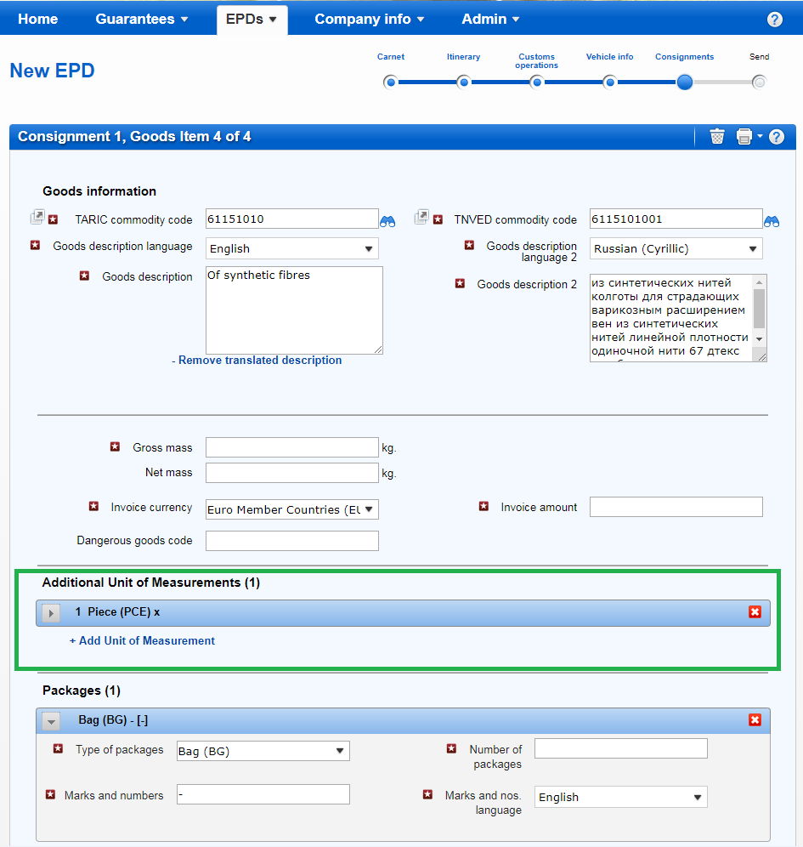

You need to open the Additional Unit of Measurement section and fill in the quantity field, in order for this information to be sent to customs:
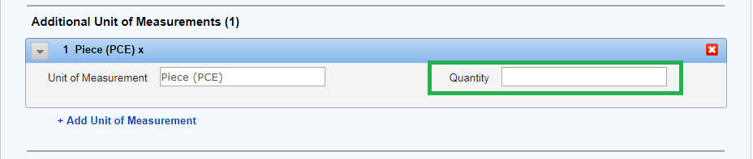

If the quantity field remains empty, the application will show you a warning message at the bottom of the page, reminding to fill in the missing value:
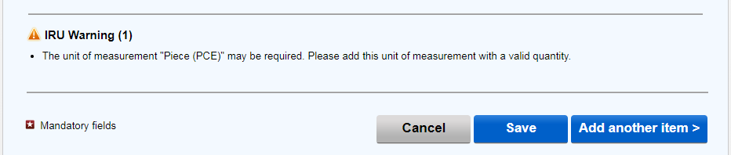

In case you do not have information about quantity or do not wish to send this information to customs, you can leave the quantity field blank or delete the section completely by clicking on the Delete icon
When sending an EPD to Belarus, it is possible to add more additional units of measurement by selecting the corresponding button: + Add Units of Measurement, and choosing the required unit from the list and indicating the Quantity:
